Why Many Traders Lose Money Even When the Trade Was Right
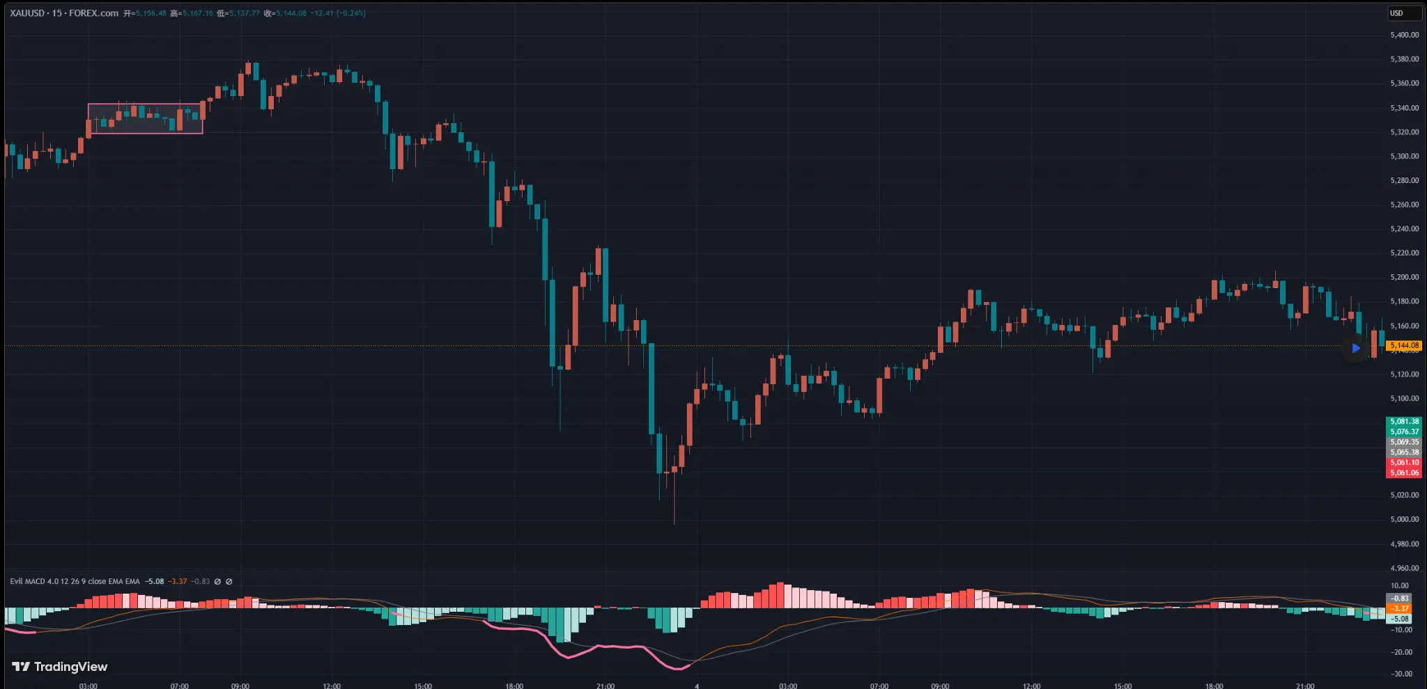
XAUUSD 15-FOREX.com Chart
Most traders lose money not because they get the direction wrong.
More often, it comes from a very common obsession:
**“I want to capture the entire move.”**
This is a misconception shared by many traders:
“I want to catch a big trend.”
“My profit is too small, I should hold longer and get more.”
It may look like simple greed on the surface, but the deeper issue is actually a **misunderstanding of what trading really is.**
At its core, trading is about forming a hypothesis about the future direction of the market.
We choose an entry point and expect the market to move in the direction we anticipate.
If we are right, the market rewards us.
If we are wrong, the market punishes us.
However, trading is not just a simple directional game.
Even if your direction is correct, you can still lose money if you fail to manage the position properly.
For example, a trade that was once in profit can easily turn into a losing trade if you refuse to take profits and simply hold until it eventually hits your stop loss.
This means that while the **entry point is important**, and a good entry can certainly improve your win rate, **exit management (both stop loss and take profit)** is equally important.
If this part goes wrong, many trades that should have been profitable may eventually end up as losses.
Let’s use a simple example.
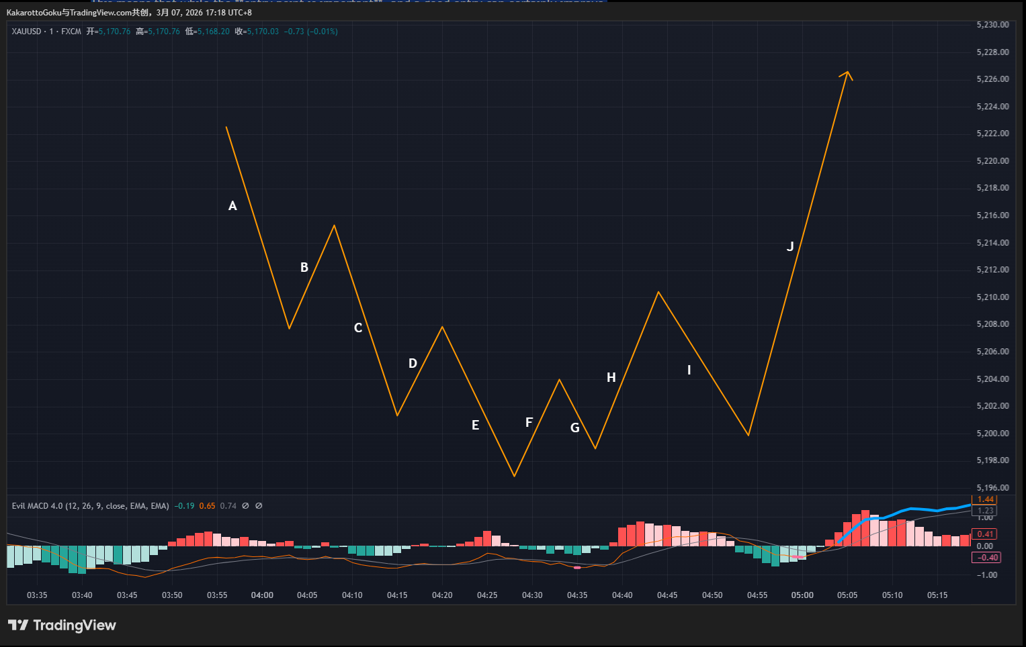
XAUUSD Trend Analysis A-J
Assume this is a market structure where the trend transitions from bearish to bullish.
Many traders in this situation try to capture the entire move.
They want their short position to ride all the way from **A to E**, capturing the full bearish trend.
Then they want to enter long at **F**, hoping to hold the position all the way up to **J**, or even beyond depending on how high the market eventually goes.
This way of thinking is exactly the conceptual mistake many traders make.
It distorts their trading goals, affects their decision making, and often leads to poor results.
As I mentioned before, the real objective of trading is to build a **repeatable trading system**.
After executing the system many times, the win rate and the risk-reward ratio can produce a relatively stable **positive expectancy**.
Trading is essentially a **probability game**.
Whether you capture a huge trend or just scalp small moves does not fundamentally matter. What matters is that the system has a **positive mathematical expectation**.
When traders obsess over catching huge moves, they often become too greedy and miss the proper time to take profits. As a result, trades that should have ended in profit eventually turn into stop-loss trades.
Going back to the example above, there are two possible approaches.
One approach is trying to capture the entire trend from **A to E**.
Another approach is to focus on the smaller pullbacks within the move, such as **B, D, and F**.
Anyone who has actually tried to trade **trend continuation pullbacks** understands how difficult it is to precisely capture a move like **A to E**.
However, with enough practice, tools like **trendlines** can help identify high-probability entry points around pullback areas like **B, D, and F**.
Now let’s compare the difference.
- **The move from A to E**: Offers a huge potential profit, which is very attractive. But in reality, it is extremely difficult to predict and hold through the entire move.
- **Pullbacks like B, D, and F**: Offer smaller profits. However, they can often be identified using structural tools such as trendlines, where market participants create a temporary consensus that the trend may continue.
At those points, we can enter the market with a **higher probability setup**, even though we cannot predict how far the market will ultimately move.
The common mistake most traders make is this:
The market only offers a small opportunity like **D**, but after entering the trade, they start expecting a massive move toward **H** or even **J**.
In other words, they replace their **trading logic** with their **personal expectations**.
Under these circumstances, the trade may initially move in their favor and produce some floating profit during the **D** segment.
But because they refuse to take profits, driven by the desire to capture a larger move, the market eventually reverses during the **E** phase and hits their stop loss.
Now consider the alternative approach.
A trader who strictly follows their trading rules might capture smaller pullback trades like **B** and **D**. These trades may produce small profits, break-even results, or occasionally small losses.
Since the full move from **A to E** cannot be predicted in advance, the trader simply accepts that fact and continues to execute the same disciplined strategy.
Later, when the market reaches **F**, the trader enters again according to the same rules.
By using **trailing stops**, the trader might occasionally capture larger moves toward **H** or **J**. Sometimes it happens, sometimes it does not. A bit of luck is always involved.
But as the market enters a bullish phase, the trader continues repeating the same process.
Most trades may end near break-even or with small results, but occasionally one trade captures a larger move that significantly grows the account.
Understanding this mindset, and translating it into actual trading behavior, is **far more important than any technical trick or indicator.**
As I often say, market profits can sometimes look like an illusion.
When we look at a chart after the fact, the move from **A to E** appears obvious. But in real trading, capturing such moves consistently is extremely difficult.
Instead of chasing these seemingly perfect trends, it is far more practical to stay grounded.
Focus first on **not losing money**.
Once that foundation is established, profits will naturally follow over time.
A common mindset of beginner traders is:
“I want to double my account.”
“I should use maximum leverage.”
“I need to capture one huge move that turns my account into 100x.”
The mindset of a mature trader is very different:
“I must control drawdown.”
“Even if I don’t make money for a while, the priority is not to lose.”
“I should avoid excessive leverage and strictly control risk.”
As for how much profit the market eventually gives — sometimes that still requires a little bit of luck.

